BANKURA UNIVERSITY
(West Bengal Act XIX of 2013- Bankura University Act, 2013)
Main Campus, P.O.: Purandarpur, Dist.: Bankura,
Pin- 722155, West Bengal
Office of the Controller of Examinations

Ref. No.: BKU/CE/UG/255/2021 | Date. 30.05.2021

Sub: Intimation for paper selection/validation for UG (Honours & Programme) Even Semesters enrolment of the A.Y. 2020-21

Madam/Sir,

Hope in this troublesome time, you are well.

Please note that we will now start the process for the UG Even Semester Examinations of the A.Y. 2020 – 21. At its first step, you are requested to select the courses corresponding to the degree-awarding subjects, which are taught in your college, by proceeding as follows.

Step 1: Login to Examination Portal using your credentials
Step 2: Click on Master menu then select College Subject Selection

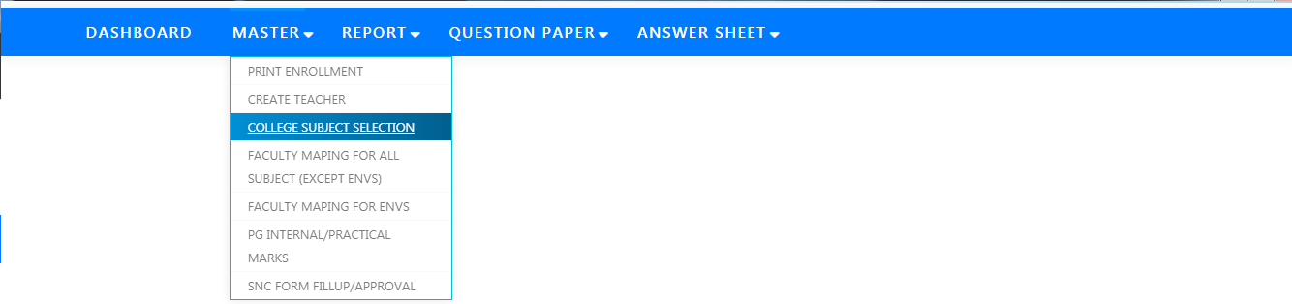

Step 3: Select Course Type (i.e., HONS/PROGRAMME), Subject (e.g., BENGALI), and chose Semester (i.e., 2, 4, 6)
Step 4: From Course Details select the courses, which are taught in your college. You may choose multiple courses corresponding to a Subject (e.g., BENGALI) at a time from the drop-down box
Step 5: Click on Save Button

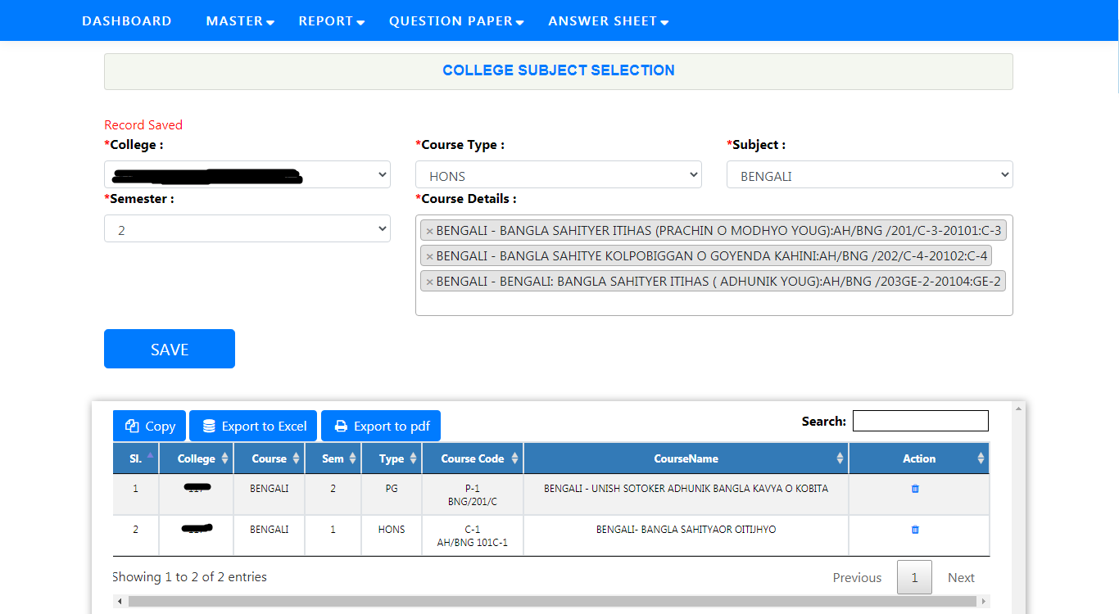

The subject validation/selection portal will remain active from 01.06.2021 to 06.06.2021.

Kindly note that (1) For Arts & Commerce Programme English-1 & English-2 for 2nd & 4th Semesters respectively have been pre-chosen automatically. You don't need to choose these two. (2) MIL Communication (AECC - 2) courses for your college have been pre-selected automatically. You don't need to choose these papers as well. You may check these using Search box.

After completion of the process, you may download the Excel file of selected courses for your ready reference. For any discrepancy feel free to email to coeug@bankurauniv.ac.in.

Your kind cooperation during this entire process is earnestly requested and highly valued.

Be safe, wear a mask & maintain social distancing.

Regards,

Sd/-

Dr. Shibaji Panda
Controller of Examinations

